Exercise 7: Advanced NoSQL Query Operators
Week: 7 (Hands-On Laboratory Exercise)
Objective: To construct advanced NoSQL queries within Node-RED utilizing MongoDB specific operators to filter ranges, apply logical gates, manipulate numerical data atomically, and manage complex JSON arrays.

Step 1: Baseline Data Initialization
To test advanced operators, we need a complex document. We will simulate an edge gateway that reports not just numbers, but arrays of attached sensors and error logs.
- Create the Inject Node: In Node-RED, drag an inject node onto the canvas. Set the payload to JSON and paste the following complex document:

{
"device_id": "GATEWAY_01", "battery": 85,
"status": "active",
"sensors_attached": ["temperature", "humidity", "soil_moisture"], "active_warnings": [{"code": 102, "severity": "low"}, {"code": 505, "severity":
"critical"}], "transmission_count": 100
}

- Execute Insertion: Wire this inject node to a mongodb4 node configured for the insertOne operation targeting your smart_campus database and devices collection. Click the inject button to insert the baseline data.

Step 2: Comparison and Logical Operators
We will use Node-RED function nodes to build dynamic query filters (assigned to msg.payload) that we pass to a mongodb4 node set to the find operation.
- Comparison Operators ($eq, $ne, $gt, $gte, $lt, $lte):
  - Drag an inject node, wire it to a function node, wire that to a mongodb4 node (Operation: find), and output to a debug node.
  - Inside the function node, write the following query to find devices where the battery is greater than or equal to 20, but less than 90, and the status is not equal to "maintenance":

msg.payload = {
"battery": { "$gte": 20, "$lt": 90 },
"status": { "$ne": "maintenance" }
};
return msg;

- Logical & Array Inclusion Operators ($or, $and, $in):
  - Create a second flow. In the new function node, write a query using $or to find devices that either have a critical battery OR contain specific sensors in their array using $in:

msg.payload = {
"$or": [
{ "battery": { "$lte": 15 } },
{ "sensors_attached": { "$in": ["soil_moisture", "co2"] } }
],
"$and": [
{ "status": "active" }
]
};
return msg;

  - Deploy and trigger both flows. Verify in the debug tab that your GATEWAY_01 document is successfully returned based on the mathematical logic.

Step 3: Atomic Field Modifiers
When updating documents in Node-RED with the updateOne operation, msg.payload must be an array: [ {query filter}, {update operations} ].
- Updating and Incrementing ($set, $inc):
  - Create a flow ending in a mongodb4 node set to updateOne.
  - We want to simulate a new telemetry ping. We must update the battery level to a new exact value, and mathematically increment the total transmission count by 1.
  - Inside the function node, write:

var filter = { "device_id": "GATEWAY_01" };
var update = {
"$set": { "battery": 82 },
"$inc": { "transmission_count": 1 }
};
msg.payload = [filter, update];
return msg;

  - Trigger the flow, then use a find node to verify the transmission_count is now exactly 101.

Step 4: Complex Array Manipulation
IoT platforms rely heavily on JSON arrays to log errors or track attached peripherals. Modifying these arrays directly in the database is far more efficient than downloading the array, modifying it in Node-RED, and re-uploading it.
- Pushing and Popping ($push, $pop):
  - Let's add a new simple sensor to the array, and remove the last item in the array simultaneously.
  - In a new updateOne function node:

var filter = { "device_id": "GATEWAY_01" };
var update = {
"$push": { "sensors_attached": "light_level" },
"$pop": { "sensors_attached": -1 }
// -1 removes the first item, 1 removes the last item
};
msg.payload = [filter, update];
return msg;

- Smart Set Addition and Removal ($addToSet, $pull):
  - If a gateway reconnects, we don't want to duplicate the "light_level" string in our array. We use $addToSet. We also want to clear out a specific error code using $pull.
  - In a new updateOne function node:

var filter = { "device_id": "GATEWAY_01" };
var update = {
"$addToSet": { "sensors_attached": "light_level" },
// Will not duplicate if it already exists "$pull": { "active_warnings": { "code": 102 } }
// Removes the specific object from the array
};
msg.payload = [filter, update];
return msg;

- Querying Complex Object Arrays ($elemMatch):
  - Finally, how do we find a device based on data inside an array of objects? We use
$elemMatch.
  - In a new find function node, search for any gateway that has a warning code over

500 with a severity of "critical":

msg.payload = {
"active_warnings": {
"$elemMatch": {
"code": { "$gt": 500 },
"severity": "critical"
}
}
};
return msg;

Part 5: Discussion & Architectural Analysis
Result:
Step 2: Comparison and logical Operators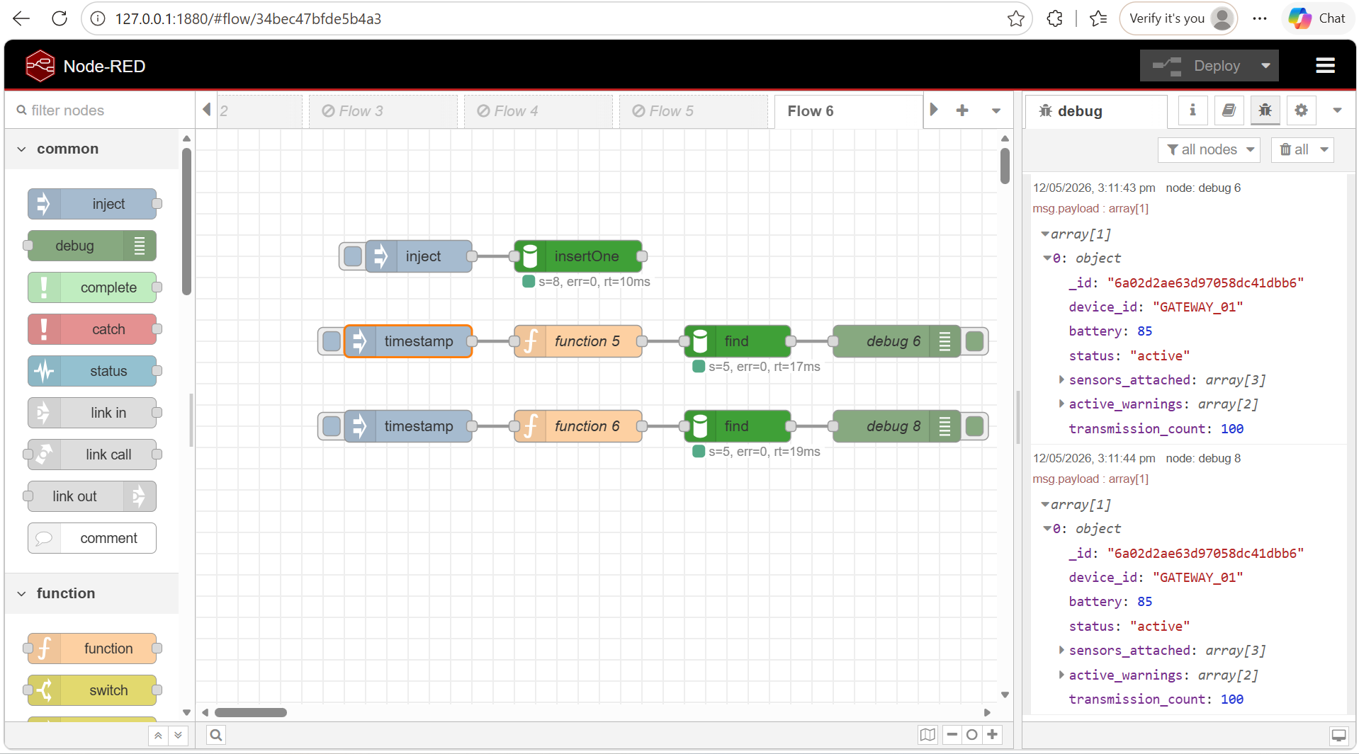

Step 3: Atomic Field Modifiers
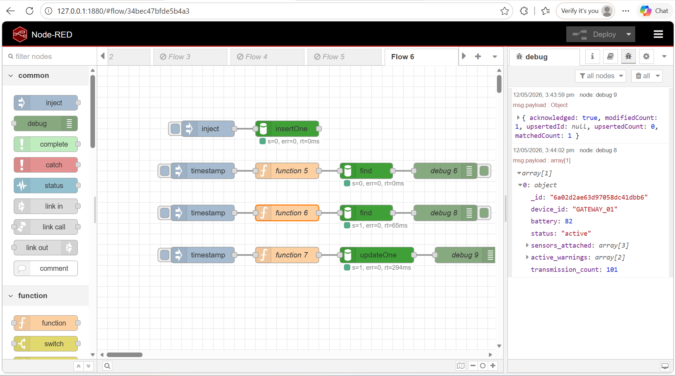

Step 4: Complex Array Manipulation
When Push operation:
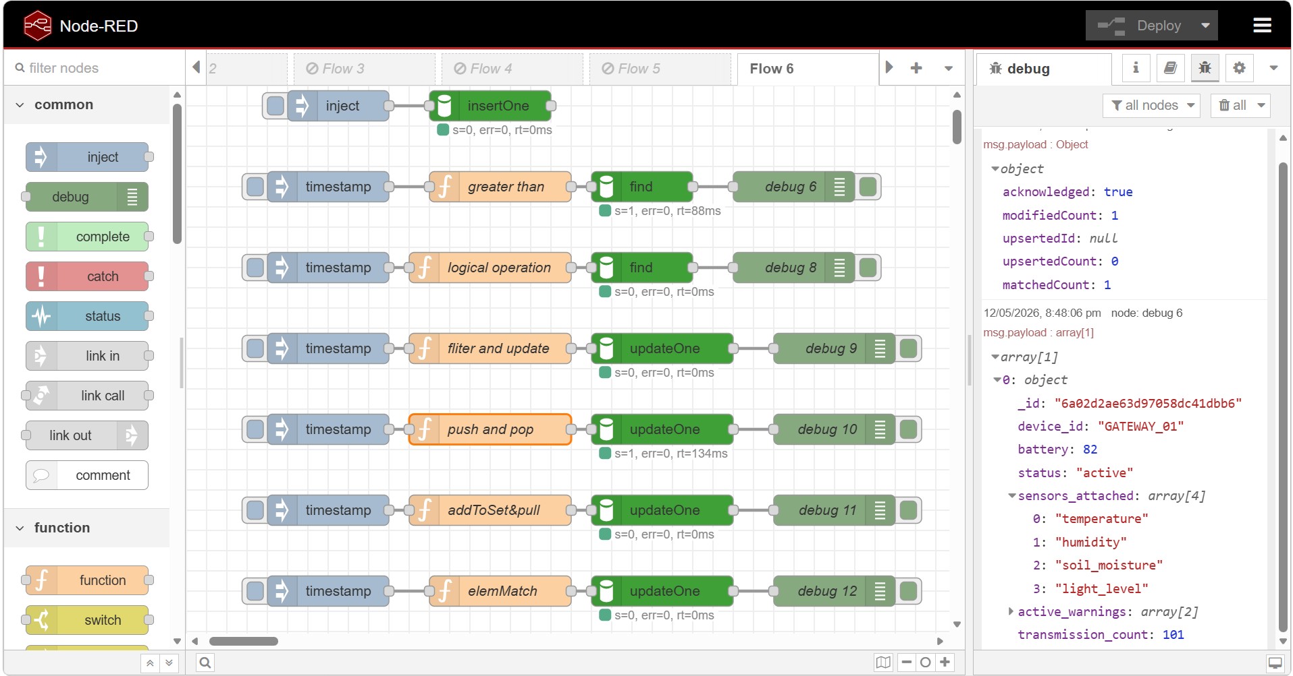

When Pop operation (-1):
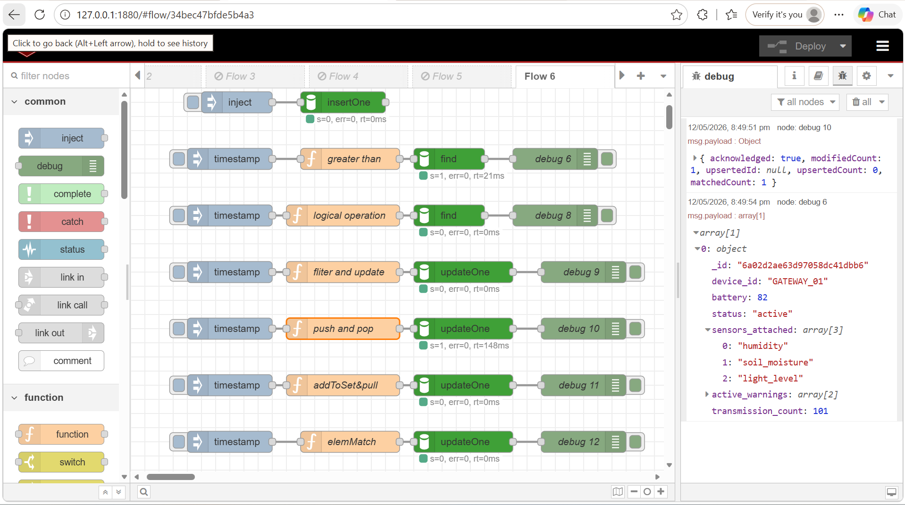

When addToSet operation:
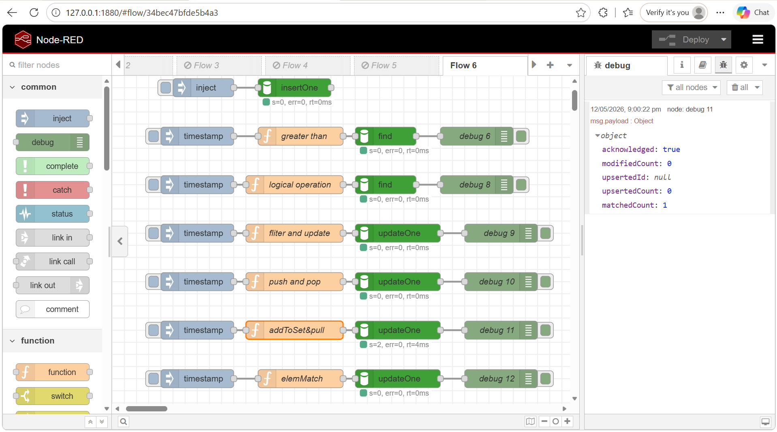

When elemMatch:
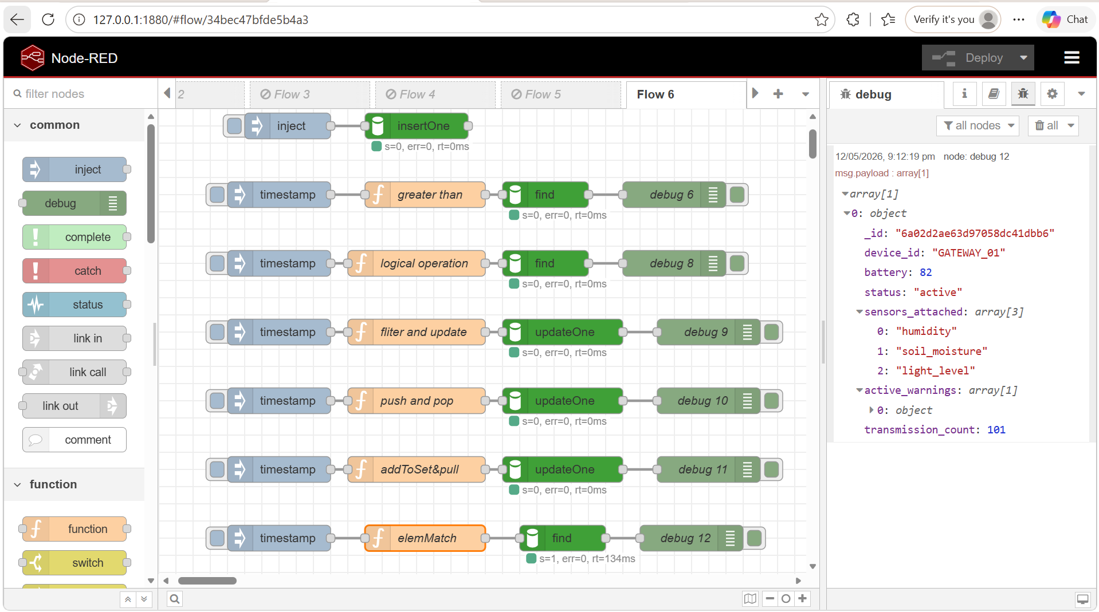

Based on your execution of these advanced operators, answer the following system design questions:
Question 1: The $inc vs. $set Paradigm
In Step 3, you used the $inc operator to increase the transmission count by 1. Why is it architecturally safer to use $inc: {"count": 1} natively in the database, rather than querying the document in Node-RED, adding 1 to the count in Javascript, and using $set to write the new total back to the database?
Using the $inc operator directly in MongoDB is architecturally safer because the increment operation is performed atomically inside the database. This means MongoDB can safely update the value even when multiple devices or users are updating the same document simultaneously. If Node-RED first reads the current value, adds 1 using JavaScript, and then writes the new value back using $set, a race condition may occur. For example, two devices may read the same value at the same time and both attempt to update it, causing one increment to be lost. By using $inc, MongoDB handles the mathematical update internally without requiring the application to retrieve and rewrite the value manually. This improves data consistency, reduces synchronization problems, minimizes database read/write operations, and provides better performance for large-scale IoT systems where many devices continuously send telemetry data.

Question 2: Efficient Payload Management
In Step 4, you utilized $addToSet and $pull to manage arrays inside the database. Describe how utilizing these native database array operators significantly reduces the network bandwidth (TCP/IP payload size) between your Node-RED middleware and your MongoDB server compared to rewriting the entire array on every update.
Using native MongoDB array operators such as $addToSet and $pull greatly improves network efficiency because only the specific modification instruction is sent between Node-RED and MongoDB instead of transferring the entire array. Without these operators, Node-RED would need to first download the whole array, modify it locally, and then upload the complete updated array back to the database. This increases TCP/IP payload size, consumes more bandwidth, and adds unnecessary processing overhead. By using operators like $addToSet, MongoDB can directly add a value into the array only if it does not already exist, while $pull can remove specific matching items internally within the database engine. As a result, the communication between Node-RED and MongoDB becomes much smaller, faster, and more efficient. This is especially important in IoT environments where sensor arrays, warning logs, and device records are updated frequently by thousands of connected devices.

